**<ENTER YOUR Project NAME>**

**Project Abstract**

**Version 1.0**

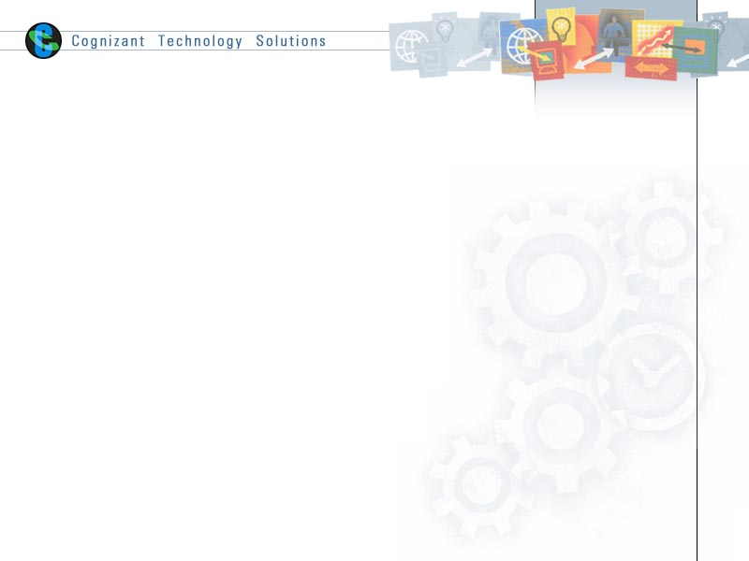

|  |  |  |  |
| --- | --- | --- | --- |
|  | Prepared By / Last Updated By | Reviewed by | Approved By |
| Name | <Project Member to fill> | <Trainer/Project Governance Representative/Cohort Mentor to fill> | <Trainer/Project Governance Representative/Cohort Mentor to fill> |
| Role |  |  |  |
| Signature |  |  |  |
| Date |  |  |  |

Table of Contents

1.0 Purpose of this document 4

2.0 Business Case 4

3.0 Appendices 4

3.1 Glossary 4

3.2 Other 4

4.0 Terms & Conditions 5

5.0 Change Log 5

# Purpose of this document

This document provides an overview about the business need and the solution that can be provided to fulfil the objective.

# Business Case

<Project Member to fill>

# Appendices

## Glossary

|  |  |
| --- | --- |
| **Acronyms** | **Definitions** |
|  |  |

## Other

# Terms & Conditions

***Disclaimer: Please do not circulate or distribute this document outside of Cognizant Network, We have a Zero Tolerance Policy. Kindly adhere to 100% Compliance at all times.***

# Change Log

*Please note that this table needs to be maintained even if a Configuration Management tool is used.*

|  |  |  |  |  |
| --- | --- | --- | --- | --- |
| Version Number | Changes made | | | |
| V<n.n> | *<If the change details are not explicitly documented in the table below, reference should be provided here>* | | | |
| Page no | Changed by | Effective date | Changes effected |
|  |  |  |  |
|  |  |  |  |
|  |  |  |  |
|  |  |  |  |